Respiration rate of tree-kangaroos in Singapore Zoo

**Objectives**

The project aims to examine the environmental influence on tree kangaroos (TKG; n = 2) in the Zoo through measurable parameters such as changes in respiration rate, body temperature, activity and behavioural patterns. The outcomes of this project could then be used to inform TKG management in climatically-similar countries within the immediate SEA region. There are plans to present this in the upcoming SEAZA conference, as well as having the research work published and/or as an appendix for a husbandry manual.

**Methods**

To examine the influence of increasing ambient temperature on the TKGs, the outdoor-housed individual would have restricted access to the BoH until 1400 h. Based on historical data (1981-2010; see Figure 1), the hourly temperature across April to June peaks at 1200 to 1400 h while a gradient of cooler temperature starts from dawn. For significance, data will be collected for 30 days for each treatment (indoor versus outdoor); preliminary analysis will begin on the 2nd week. After 30 days, males are swapped between exhibits, and data is re-collected again (i.e., 60 days altogether per individual).

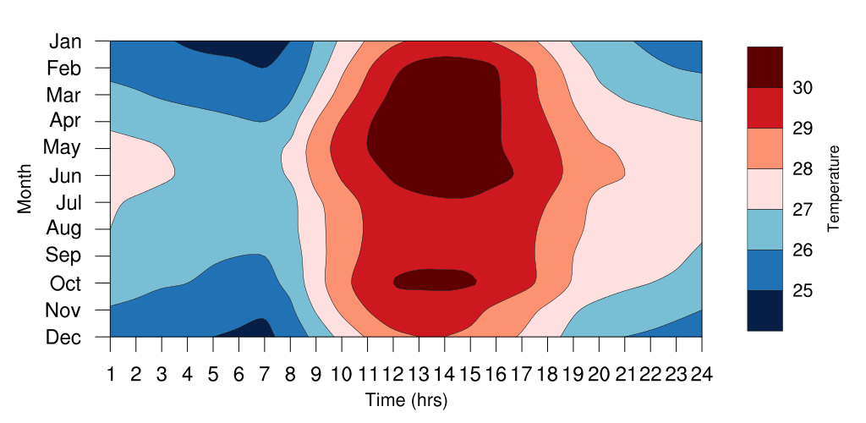

Figure 1: The hourly variation of temperature for each month (1981 – 2010). Data obtained from Changi Climate Station (www.weather.gov.sg).

Here, the section is aiming to collect (up to) six instantaneous focal observations daily, with each sample lasting five minutes. All observations are collected through ZooMonitor and the behaviours used for constructing the ethogram and their brief descriptions can be found in Table 1. With each observation, the temperature of the TKG’s forearm, body and ears are taken while environmental parameters such as temperature, humidity and climate are recorded. The spatial use of the observed animal is also collected. As the zonification of the indoor and outdoor exhibit are designed to examine thermoregulation, special considerations are given to furnishings that encourage refuge-seeking (e.g., sheltered platforms) as well as heat-avoidance behaviour (e.g., distance from open-air window).

Analysis is relatively straightforward. Activity (e.g., H-index or Shannon’s index of diversity) and spatial use (e.g., modified SPI) are compared through descriptive statistics. Temperature (body, ear and forearms) are correlated to answer a separate research objective. Lastly, ear temperature, as a response, is fitted into linear regression models where predictors such as ID (hence age), climate, shelter use% and inactivity are considered.